Our next Leadership Committee meeting Thursday, March 13th. Here are the items that I came up with for discussion. If any of you have any other topics, please post them via email to the Leadership group ("Pack 618 Leadership" <pack-618-leadership@googlegroups.com>).
March Leadership Committee Agenda
- Call To Order
- Leader's Reports
  - Cubmaster
  - Treasurer
  - Den Leaders
- Pack meeting - Schedule Of Events
  - Opening - pledge, etc.
  - Announcements
  - Scout Activities – Tigers – Litter-to-Glitter activity
  - Closing

Topics for discussion:
- Fort Knox & Extra Space Storage goodwill projects – Have the Scouts do some project at storage facilities. Early June?

- Donation for Scouting In Iraq
- How much did we collect at B&G?
- Patches – Do we want to offer them for sale to our Pack? Must sell for at least $10.00, with anything above cost going to the Scouting In Iraq effort.
- Hold a fund-raiser? Maybe a small Boy Scout/Cub Scout softball tournament with concessions & entry fee?

$1.91 each / 300 pieces
$2.26 each / 200 pieces
$3.17 each / 100 pieces

Description: 5” x 2” CSP shape patch, 6 colors, rolled edge, 100% embroidered, and iron on backing. Please refer to the attached sample patch.
$1.90 each / 300 pieces
$2.30 each / 200 pieces
$2.97 each / 100 pieces

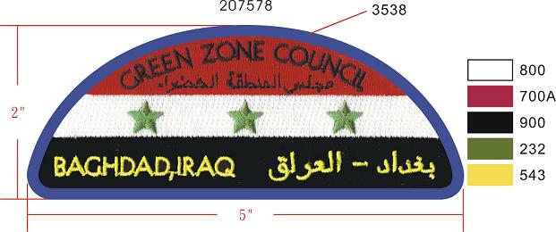
- Jim Davidson-Troop 540 wants to buy needed items and send them rather than just send a check to BSA earmarked for Iraq. He's trying to find out what they want.

- Storage – Cleaned out some junk and most all food-stuffs. There are large jugs of juice that will be thrown away if no one can tell me how old they are. Safety issue. Do we want to be responsible for someone getting sick due to an item going bad in the storage unit?

- Purchasing grills. I'm thinking that 2 or 3 Weber Baby-Q grills with tank and hose would be sufficient.

- Bike Hike – Jason Carlisi is heading it up. I'm working with him to organize, although I haven't heard much from him. Do we want to turn it into a bike-hike and picnic? Jason's checking into using Martin Road park. Wanted to use gazebo at Lake Elkhorn but Jason said it was $40.00/hour.

- Den Finances – I keep hearing that Den leaders are funding their den's activities through the use of personal funds. I VERY STRONGLY urge you to seek reimbursement from the Pack (up to the $10.00/Scout maximum that was agreed upon previously). If you need additional funding, consider “dues” that are collected at each meeting (or monthly; however you choose). When you take on a leadership role, you DO NOT take on financial responsibility for that role! I think that most of us that were in Scouts can remember paying dues at each den meeting. I'm not sure why we got away from that concept, but it serves a couple of good purposes. The first being that the Scouts gain an understanding that there is a cost for participation. The second being that dues provide funding for materials and activities.

- Pack Meeting:
- Need to identify and congratulate those that participated in Scouting For Food. Talk about how important this is to our community.

- Talk about bike-hike and Navy vs Johns Hopkins game. Have Jason and his son stand up and let everyone know that they will be heading up bike hike. It's important to talk about being a leader in the Dens and Pack and taking on an assignment with your Scout. Lead and teach by example.

